Primary 5 Learning Plan.
Term: 1A Date: September/October 2018
TOPIC –Castles
 | Reading | Writing | Talking & Listening
Literacy | - Know and understand the term 'historical' in relation to story and identify clues which suggest texts are older, e.g. language use, vocabulary, archaic words.  - Understand how the fiction genre determines settings and characters.  - Know how to analyse character and setting by studying the language used.  - Understand how dialogue is presented in stories, e.g. through statements, questions, exclamations.  - Understand and use the terms 'fact' and 'opinion' and begin to distinguish the two in reading and other media.  - Know how to use terms 'fiction', 'non-fiction', 'fact' and 'information' appropriately.  - Understand how and why information is organised in certain ways, e.g. contents, index, headings, sub-headings, page numbers, etc.  - Understand and use the term 'noun'. Distinguish between common and proper nouns.  - Identify verbs in sentences; collect and classify verbs.  - Extend understanding of prefixes and how prefixes generate meaning.  - Investigate compound words and recognise that they can aid spelling even where pronunciation obscures it, e.g. cupboard  - Understand how to use dictionaries, thesauruses and glossaries in hard copy and digital form.  - Use 3rd and 4th place letters to locate and sequence words in alphabetical order.  - Generate synonyms for high frequency words.  - Study the work of a well known poet and show a preference. | - Talk about and plan their writing with teacher and/or peers.  - Use different ways of planning stories, e.g. brainstorming, notes, diagrams.  - Plan a story identifying the stages of its telling, indicating an awareness of genre, e.g. historical  - Develop the use of setting in stories by: 1) writing short descriptions of known places, 2) writing a description in the style of a familiar story  - Write character sketches, focusing on small details to evoke sympathy or dislike.  - Use paragraphs to organise dialogue and structure stories.  - Make a simple record of information from texts read, e.g. by completing a chart of information discovered, by listing key words, drawing together notes from more than one sources.  - Write poems based on personal or imagined experience, linked to poems read.  - Understand the importance of editing and revising own writing. | - Speak clearly and coherently to a wide range of audiences for a variety of purposes.  - Understand and learn to respond to feedback.  - Use and reflect on some ground rules for sustaining talk and interactions.  - Offer reasons and evidence for their views, considering alternative options.  - Sustain conversation.  - Understand and learn to respond to feedback.

 | Number | Measures | Shape & Space | Handling Data
Numeracy  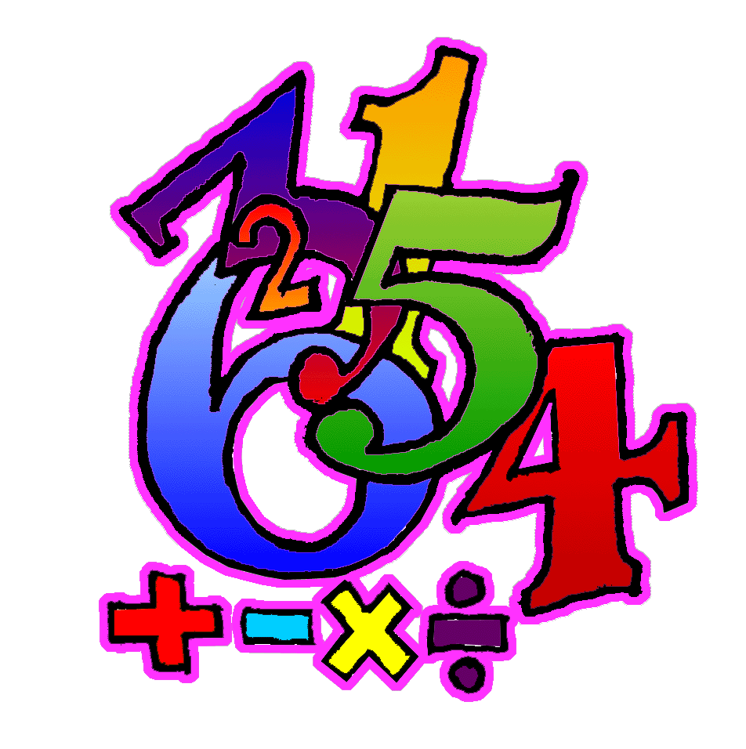 | - Count, recognise, read, write, order and work with numbers within 9999.  - Know number ‘after’ within 9999.  - Know number ‘before’ within 9999.  - Know number ‘between’ within 9999.  - Find missing numbers in a sequence (increasing and decreasing) within 9999.  - Use knowledge of place value to develop a standard written method for vertical subtraction HTU (with exchange: decomposition), estimating the answer before calculating.  - Solve a range of addition and subtraction problems, using both written and mental calculations, selecting the operation required.  - Understand the 3 times multiplication facts as repeated addition, and as arrays. Develop quick recall, using understanding of commutativity.  - Understand the 4 times multiplication facts as repeated addition, and as arrays. Develop quick recall, using understanding of commutativity.  - Understand relationships between all coins and notes.  - Use efficient methods to find the totals of a mixed group of coins and notes totals up to £10.00 (e.g. by starting with the highest value coins or notes, or by grouping lower value coins into £1 piles). | - Estimate, measure and record lengths in cm and/or m and cm.  - Convert between cm and m &cm e.g. 320cm is equal to 3m and 20cm.  - Understand concept of perimeter.  - Find perimeter of simple shapes.  - Estimate, measure and record weights using kg and g.  - Know the number of days in each month and use to calculate durations across a month. | - Sort, name and recognise and describe 2D shapes, using number and length of sides, number of corners, number of right angles, number of lines of symmetry, stating whether they are regular or irregular.  - Identify angles as being an amount of turn smaller or larger than one right angle.  - Use terms acute and obtuse to categorise angles. | - Use ICT software to represent data in a variety of ways and decide which is the most appropriate, giving reasons for their choice.
Processes: (Ongoing throughout the year, but all processes activities this term will be linked to areas covered above as well as revising previous concepts).
- Begin to organise own work and to work systematically.
- Solve simple two-stage problems set in real life contexts.
- Begin to suggest how to present findings.
- Use a writing frame to plan what is needed to start solving a problem.
- Talk about how they carried out a task.
- Discuss and respond to open ended questions.
- Discuss and compare ideas and methods with others.
- Where appropriate, select or design a writing frame to plan work.
- Explain their thinking.
- Compare own methods/findings/presentation with that of others.
- Begin to explore and use a range of problem solving strategies, persevering when difficulties are encountered.
12. Check accuracy of own work and findings

