Primary 4 Learning Plan.
Term: 1A Date: September/October 2018
TOPIC –Castles
 | Reading | Writing | Talking & Listening
Literacy | - Know and understand the term 'historical' in relation to story and identify clues which suggest texts are older, e.g. language use, vocabulary, archaic words.  - Understand how the fiction genre determines settings and characters.  - Understand how dialogue is presented in stories, e.g. through statements, questions, exclamations.  - Understand and use the terms 'fact' and 'opinion' and begin to distinguish the two in reading and other media.  - Know how to use terms 'fiction', 'non-fiction', 'fact' and 'information' appropriately.  - Understand how and why information is organised in certain ways, e.g. contents, index, headings, sub-headings, page numbers, etc.  - Understand and use the term 'noun'. Distinguish between common and proper nouns.  - Identify verbs in sentences; collect and classify verbs.  - Extend understanding of prefixes and how prefixes generate meaning.  - Investigate compound words and recognise that they can aid spelling even where pronunciation obscures it, e.g. cupboard  - Understand how to use dictionaries, thesauruses and glossaries in hard copy and digital form.  - Use 2nd and 3rd place letters to locate and sequence words in alphabetical order.  - Generate synonyms for high frequency words.  - Study the work of a well known poet and show a preference. | - Talk about and plan their writing with teacher and/or peers.  - Use different ways of planning stories, e.g. brainstorming, notes, diagrams.  - Plan a story identifying the stages of its telling, indicating an awareness of genre,  - Develop the use of setting in stories by: 1) writing short descriptions of known places, 2) writing a description in the style of a familiar story  - Write character sketches.  - Use paragraphs to organise dialogue.  - Make a simple record of information from texts read, e.g. by completing a chart of information discovered, by listing key words, drawing together notes from more than one sources.  - Write poems based on personal or imagined experience, linked to poems read.  - Understand the importance of editing and revising own writing. | - Speak clearly and coherently to a wide range of audiences for a variety of purposes.  - Understand and learn to respond to feedback.  - Use and reflect on some ground rules for sustaining talk and interactions.  - Offer reasons and evidence for their views, considering alternative options.  - Sustain conversation.  - Understand and learn to respond to feedback.

 | Number | Measures | Shape & Space | Handling Data
Numeracy  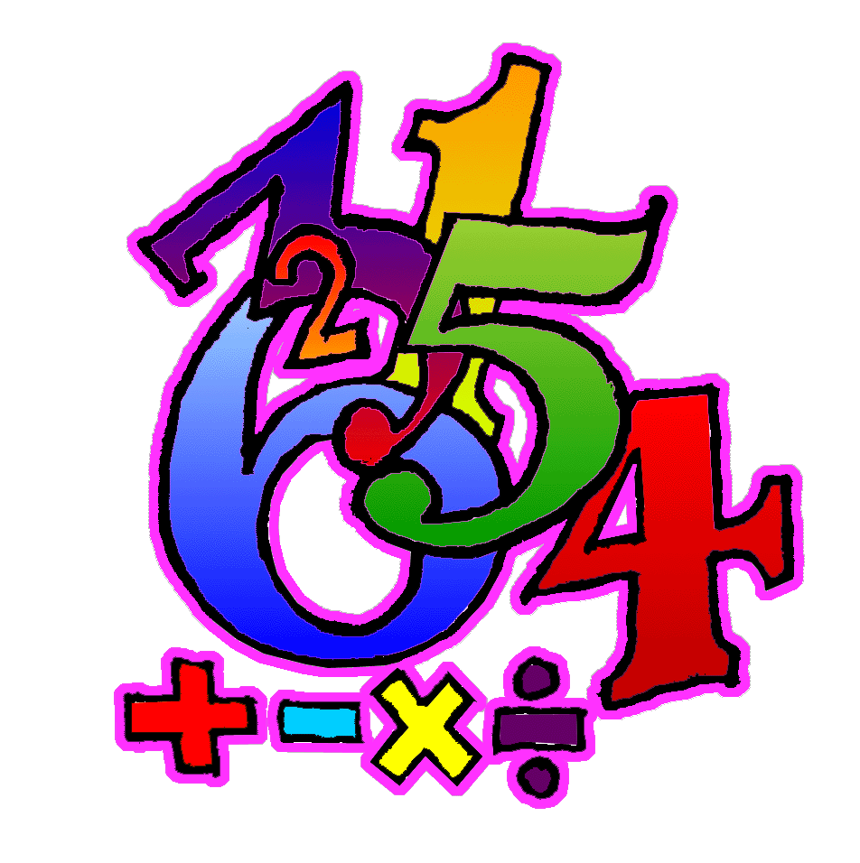 | - Count, recognise, read, write, order and work with numbers within 500.  - Know number ‘after’ within 500.  - Know number ‘before’ within 500.  - Know number ‘between’ within 500.  - Find missing numbers in a sequence (increasing and decreasing) within 500.  - Round numbers within 100 to the nearest 10.  - Use knowledge of place value to develop a practical method for vertical addition TU (with carrying).  - Understand that addition and subtraction are inverse operations, use to check answers and use complementary addition to solve a subtraction calculation.  - From 3 given numbers within 10, give 2 addition and 2 subtraction facts.  - Use efficient methods to find the total of a mixed group of coins totals up to £1.00 (e.g. by starting with the highest value coins, or by grouping lower value coins into 10p piles).  - Understand the relationships between coins up to £1.00. | - Develop an appreciation of the length of 1 metre.  - Approximate measurements appropriately. (e.g. if an object is not exactly 1m long, choose the most appropriate way of recording the measurement: e.g. less than 1m, just under 1m, just over 1m etc.)  - Develop an appreciation of the weight of 1Kg.  - Approximate measurements appropriately. (e.g.) if an object is not exactly 1Kg in weight, choose the most appropriate way of recording the measurement: e.g. 1Kg and a bit, more than 1Kg but less than 2Kg, between 1Kg and 2Kg etc)  - Understand use of am and pm.  - Know there are 24 hours in one day, am = 12 hours and pm = 12 hours.  - Know there are 60 minutes in one hour and use to deduce that half hour = 30 minutes and quarter hour = 15 mins.  - Understand and use quarter to: analogue and digital time. | - Understand and use concept of symmetry through practical activities. Recognise one line of symmetry in a variety of 2D shapes, designs and pictures.  - Fit shapes together to make new shapes (e.g. tangrams).  - Sort 2D shapes into those with square corners and those without. | - Represent data from frequency tables as bar charts (vertical and horizontal), using paper and ICT, correctly labelling the axis.  - Understand the terms vertical axis and horizontal axis.  - Interpret given and self-constructed bar charts.
Processes: (Ongoing throughout the year, but all processes activities this term will be linked to areas covered above as well as revising previous concepts).
- Select appropriate materials and equipment for a task through an understanding of their special characteristics.
- Choose and use appropriate number operations and ways of calculating in a wide range of contexts.
- Suggest the information needed to carry out a task, how to obtain the information and ways to record it.
- Ask questions to clarify information.
- Discuss and respond to open-ended questions.
- Present findings in an appropriate way.
- Begin to talk about how they carried out a task.
- Review own way of working with (teacher/peers).
- Consider alternative ways of working (with teacher/peers).
- Check accuracy of own work (with teacher/peers).

