Dromore Road Primary School

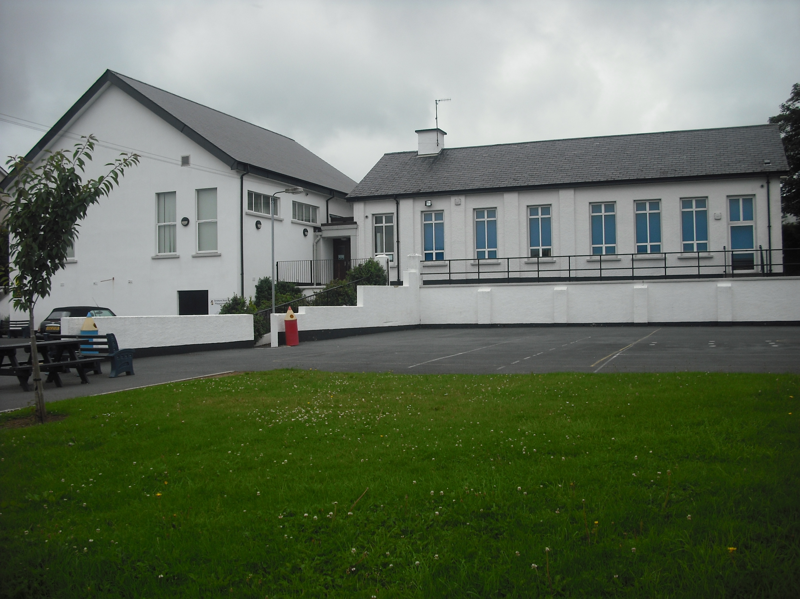
Dromore Road is a small controlled Primary school situated in the town of Warrenpoint. We provide education for children from Y1 – Y7.

PASTORAL CARE POLICY


2017/18

INTRODUCTION

Pastoral Care is not a frill or option; it is the oxygen essential for the learning process to occur.
McGuinness (1989)

Parents are the primary educators of young people. The responsibility and impact of the home environment in the formative years is acknowledged as the most important influence on the development of the adult person.

However, there are numerous other influences which come from a wide range of other sources. Central to these influences is the role of schools, and more specifically teachers, who will have contact on a daily basis with children and young people from 4 to 18 years of age. It is paramount that those charged with the responsibility of educating young people must be aware of the crucial importance of their role.

To develop as a person is to develop in all five dimensions of life – physically, intellectually, emotionally, socially and spiritually. In recognition of this we must adopt a proactive stance in taking a holistic approach to the development of our young people.

Personal Development provides the means for our young people to clarify their values and attitudes. It assists young people in the development of personal skills which in turn leads them to an acceptance of responsibility for themselves and for their actions. Personal Development must be firmly rooted in the belief that all people have value in their own right, and that their feelings, opinions and actions are important, regardless if these correlate with those of others or not. In practice this means that we as teachers endeavour to communicate openly and honestly with our pupils and enter into genuine sharing relationships. Most significantly, it means that we must place confidence and trust in the ability of others to take responsibility for themselves, their behaviour, their feelings, their attitudes and their learning. We must provide and allow for the development and awareness of self, and all that this entails.

Carl Rogers suggests that when individuals come in contact with, own, and accept their inner strength, a new way of living emerges for them. Pastoral Care provides the conditions in which the constructive power within can be released and used to its fullest advantage.

The mutually beneficial outcomes of developing Pastoral Care and Personal Development and Mutual Understanding are:

- increased self awareness

- development of high internal self-esteem

- confidence and independence of thought

- sensitivity to the needs of others.

In addition, young people especially develop the necessary skills to cope with possible risks to their personal safety from a range of threats. They become empowered to meet the demands and challenges of adult and working life with confidence.

What this means for Pupils

This means encouraging pupils:
- To set and achieve personal, social and academic goals through a planned and developmental programme
- To help them gain maximum benefit from their time in school in order to reach their full potential – morally, intellectually, physically, socially, creatively and emotionally
- To recognise and relate to the school’s ethos
- To develop independence of mind and to take responsibility for their own actions and learning
- To develop self discipline and self respect
- To develop an understanding of themselves as individuals, recognising their strengths and limitations, their personal qualities, their attitudes and values
- To develop a respect for the opinions of others and the rights of others and show tolerance towards them
- To develop an understanding of the world in which we live
- To foster relationships where they feel happy and secure
- To understand the importance of a healthy and positive lifestyle and strive to achieve this.

What this means for Teachers

- Establishing a clear vision of the school with its pupils and its community
- Developing whole school policies which establish principles for action throughout the school
- Promoting a caring environment where pupils’ learning is developed within the context of their individual needs and abilities
- Providing them with opportunities for their own professional development
- Establishing appropriate structures of time and support for those in need
- Being aware of the children’s individual background and experiences and individual needs and aspirations
- Fostering relationships where children feel happy and secure and can approach the class teacher for any reason
- Reinforcing the importance and benefits of a healthy lifestyle.

What this means for other adults in the school
Classroom / Supervisory assistants, Clerical Assistants etc.

- Understanding and having empathy with the general ethos of the school
- Being partners with teachers in providing a caring approach
- Helping pupils achieve their personal goals
- Developing a team approach where each member has a particular role to play
- Being aware of the children’s individual backgrounds and experiences and individual needs and aspirations.

This policy has been compiled with the collaboration and support of the teaching staff at Dromore Road Primary School and in consultation with all auxiliary staff, parents, school council and Board of Governors.

Dromore Road Primary School
Pastoral Care Policy

Rationale

Pastoral Care is a priority within Dromore Road Primary School; we define Pastoral Care as the created ethos through which our pupils develop and learn to their optimum potential. We provide the opportunity for every pupil to develop into responsible, self-aware, confident, and capable young people equipped to cope with the challenges of the 21st century.

Dromore Road Primary School accepts that Pastoral Care must form the basis of, and permeate, all aspects of the curriculum.

We recognise that the lifelong learning process begins at home and would emphasise the importance of partnership between school, home and the community.

Vision and Values

Dromore Road Primary School subscribes to the view that every pupil has a right to feel safe and secure on all levels. We will actively promote a Pastoral Care ethos which allows for the development of the whole person, and which leads to every pupil making good choices which will form the basis for a healthy and positive lifestyle.

It is also important to remember that schools are centres of education and we therefore accept the validity of a personal development approach rather than a delivery which is service driven.

We aim to ensure that:

- Pupils feel secure and happy at school and understand that they can speak to staff regarding concerns, in and outside school, e.g. ‘Who can help?’ notice board, staff on duty, assemblies, NSPCC visit
- Pupils develop a sense of self-esteem and awareness of the needs of others e.g. through PDMU lessons, circle time, rewards assemblies
- The values, beliefs and concerns of pupils are taken seriously e.g. Class, School and Eco councils, suggestion and worry boxes
- There is a promotion of positive relationships, mutual tolerance and respect for others throughout the school e.g. Playground Friends, School Council, P7 mentoring P1’s
- All members of staff feel valued and work as part of a team e.g. regular meetings, good communications between all staff
- Good communications are maintained between parents and school e.g. Parent Interviews, Annual Report, Assemblies, Newsletters, school website.

School as a Community

The school as a community should be seen as an extended family where everyone works for the common good. For example:
- Parents will be made welcome in the school and encouraged to feel that their role is important and appreciated
- Parents will be encouraged to show their support in a variety of ways, eg PTA, homework, parent workshops, school trips, parent/teacher meetings, sports events, parent led extra-curricular activities, school concerts etc.
- Parents will show respect for teachers
- Teachers will share duties as part of a mutually supportive team.

School as part of the Wider Community

- The assistance of outside agencies will be sought to extend pupils’ learning experiences, eg. PSNI (Police Service of Northern Ireland), NIFRS (Northern Ireland Fire and Rescue Service), School nurse, CAPS (Child and Parent Services) etc.
- Links will be encouraged with neighbouring schools, both the Preschool, Primary and Post Primary
- There will be links with statutory agencies involved in the health and welfare of children, eg. Pupil and Personal Development (SELB), Social services, ACE (Action for Children in Education) team.

School in the Community

- The school will have close links with local bodies, eg churches, community organisations, businesses and charities.
- The school will use and involve the wider community in a variety of ways, eg environmental projects, through Shared Education lessons, trips to the park and beach, local library etc.

Ethos

Ethos is an intangible concept with a tangible effect. It is our intention to establish an ethos which may be detected in the feelings of security at every level within our school. The Pastoral care of our children is central to everything that takes place at Dromore Road Primary School. All staff have a responsibility to contribute to the Pastoral dimension of school life.

This may be achieved through:

- Creating a sense of belonging amongst all strands of our school
community
- Developing an atmosphere of mutual respect and caring
- Creating an explicit Pastoral Care approach which allows for a fair and
equitable exchange of views/ideas/attitudes, etc. in an atmosphere of
trust
- Implementation of a Positive Behaviour policy which creates a full sense
of justice and fair play amongst our school community
- Providing opportunities for every person to succeed and to be affirmed in
their self-worth
- Promoting positive relationships at every level where each person is
valued, respected and encouraged to value and respect others
- Working with parents for the mutual benefit of all
- Establishing and maintaining links with the wider community
- Affirming and actively promoting staff to develop positive attitudes
towards themselves and to the pupils in our care
- Creating a sense of self-worth at every level.

Child Centered Provision

At Dromore Road Primary School we aim to meet the needs and aspirations of the pupils within the school through endeavouring to promote a safe, stimulating and positive environment in order that everyone can develop those personal and social skills necessary to thrive within our school community.

Each teacher is concerned with the personal development and well-being of the individual pupils in their class. Pupils are encouraged to develop an awareness of the needs of others, to take responsibility for their own actions and to develop self-respect and self-esteem. We believe that the school is a community within a community and therefore aim to develop good relationships, based on respect, between pupils, staff and parents.

We promote equality of opportunity, high quality learning, a concern for individual pupils and a respect for diversity. The school values every pupil as an individual and seeks to provide equal opportunities through adopting a range of teaching strategies and offering a wide range of in-school and after-school clubs.

We seek to meet the additional educational and other needs of pupils and to help them overcome barriers to learning. Class teachers plan and teach differentiated work where appropriate. Mrs R McIlroy (SENCo) and Mrs G McKee offer withdrawal support for Literacy and Numeracy and Mrs R. McIlroy works closely with a variety of agencies (e.g. PPDS, Education Psychology) to provide additional support when needed. Mrs S McGrath is responsible for the individual needs of our Newcomers, which involves monitoring of CEFR (Common European Framework of Reference for languages) forms for relevant children.

We believe in and support pupil participation and involvement in decisions about school life. We do this through our Playground Friends system, School Council and Eco Council. Mrs K Graham co-ordinates the Playground Friends and School Council. Mrs O Graham co-ordinates the Eco Council.

The school follows guidelines set out in our Child Protection and E-Safety Policies fully. All members of staff have full Child Protection training biannually and annual refresher training. The safeguarding team are regularly trained.
We support children in making healthy choices through the provision of a healthy environment. We have a Healthy Break Policy and encourage all pupils to drink water. A range of sporting clubs, after-school activities, coaching sessions i.e. IFA, and PE lessons provide children with the opportunity to be active. We operate an extensive programme for Years 4-7.

Relationships

Excellent relationships foster and develop in an atmosphere of respect. All staff work hard to establish positive working relationships with the pupils.

In our school we will work towards creating opportunities where mutual respect can grow and develop. We aim to create a caring, empathetic and secure environment where our young people can develop good relationships based on those they experience. We promote positive relationships through PDMU lessons, school trips, extra-curricular activities, School Productions, assemblies and Parent Teacher Association events.

Professional Counselling

The value of professional counselling should never be underestimated. A counsellor can offer immense support to a young person who needs help and guidance. Our school will endeavour to enlist the support of Professional Counsellors if necessary to provide specific support.

High Quality Teaching and Learning

We provide a broad and relevant curriculum as is evidenced by our planning and teaching. The school will strive to achieve a number of the aims of this policy through the Personal Development and Mutual Understanding (PDMU) strand of the Revised Curriculum.

Staff will respond to other social, community and class issues as they arise, using their professional judgement and the Revised Curriculum. In certain circumstances outside agencies may be invited into school to support the work of staff in delivering the curriculum or dealing with pastoral issues.

Teachers use a range of teaching strategies that respond to the diversity within the classroom such as individual, paired and group tasks, talking and listening activities, role play and drama and a wide range of active teaching methods. Circle Time is also an excellent tool in supporting pastoral issues.

Teachers reflect on their own work and the outcomes of individual pupils through the effective use of data, evaluations and classroom observations.

A School Connected To Its Local Community

Good relationships and communication between the school and its parents and the wider community are crucial to our pupils’ health and well-being, learning and achievement. These links are developed by encouraging active involvement in our school, through:

- School website
- Regular Parent/Teacher consultations
- Annual school reports
- Open day
- School plays/assemblies
- PTA events
- Parent support in areas of the curriculum
- Links to the local nursery and secondary schools
- Local clergy at assemblies
- Shared lessons with St. Bronagh’s

We have good links with other relevant statutory and voluntary agencies that support pupils’ health and well-being, learning and achievement. These include Social Services, the school nurse, school dentist and Pupil Personal Development Services.

The school is involved with specific programmes and resources that meet the needs of the community and nearby schools. These are:
- School Sensory Garden
- Community play area
- Heart Start First aid training
- PSNI/Fire Service
- CEF (Child Evangelistic Fellowship)
- Affiliated sports coaching
Managing External Agencies

We acknowledge the importance of ensuring that any external agencies used to support our work with young people must adhere to the values and ethos particular to our school. Schools need to be aware of the importance of a contract being agreed upon by all contributory parties. In the event of additional external support being required the Principal, Pastoral Care coordinator and staff will work closely to ensure the child is kept at the centre.

Training and Support

In order to support staff our school recognises the importance of training as a priority area in the establishment of a caring and pastoral environment. Such training will take place as and when the need arises.

Staff Welfare

The Principal and Board of Governors believe in an appropriate life/work balance and understand that there will be times when staff will, for valid personal reasons, require an increased level of support and understanding. Staff should feel that they are able to share concerns with their Principal and know that they will receive compassionate support.

Related School Policies

This policy is set within the broader school context of Pastoral Care and as such should be read in conjunction with the following school policies:

- Personal Development Curriculum Policy
- Child Protection Policy
- Misuse of Drugs/Substances Policy
- Positive Behaviour Policy
- Anti-Bullying Policy
- Intimate Care Policy
- Code of conduct Policy
- Administration of Medication Policy
- Relationship and sexuality Policy
- E-safety Policy

ROLES AND RESPONSIBILITIES

It is important that all individuals recognise their responsibilities in implementing the Pastoral Care Policy.

School Member | Responsibilities
TEACHING STAFF | - Demonstrate by example the high standards of personal and social behaviour we expect of our pupils.  - Develop a good rapport, with pupils taught to foster an environment of mutual respect in classroom.  - Plan and deliver PDMU lessons using relevant themes and resources as well as other appropriate material.  - Help children to achieve their potential by setting appropriate expectations and providing support and encouragement.  - Encourage children to accept personal responsibility for their behaviour.  - Be alert to signs of distress and encourage pupils to speak to an appropriate adult.  - Listen to children who come to you with a problem, take what they say seriously and act to support and protect them.  - Record minor incidents in the class incident book and Individual Pupil Overview and inform Principal to monitor patterns of concern.  - Refer to Anti-Bullying Policy if bullying is suspected.  - Maintain good communication with parents through meetings, annual reports, written comments on homework/notes home and verbal feedback.  - Attend in-service training on Pastoral Care and related issues, when available.  - Be familiar with the school Pastoral Care Policy and be aware of current educational research and initiatives related to these issues.  - Adhere to the school policy of confidentiality
AUXILIARY STAFF | - Demonstrate by example the high standards of personal and social behaviour we expect of our pupils.  - Develop a good rapport with pupils and foster an environment of mutual respect in school.  - Be alert to signs of distress and encourage pupils to speak to an appropriate adult.  - Listen to children who come to you with a problem, take what they say seriously and act to support and protect them.  - Report minor incidents to class teacher.  - Report concerns to class teacher if bullying is suspected.  - Adhere to the school policy of confidentiality
PRINCIPAL/  PASTORAL CARE COORDINATOR | - Attend all relevant training and disseminate to colleagues. Facilitate staff briefings and in-service training  - Ensure that the policy is a living document which is communicated to the school community.  - Facilitating regular monitoring and review of Pastoral Care procedures.  - Foster effective communication between school and home.  - Adhere to the school policy of confidentiality.  - Consult with external agencies (where appropriate), including Educational Welfare and PSNI.
GOVERNORS | - Be familiar with school policies and procedures.  - Ensure that all policies and procedures are implemented and reviewed as appropriate.  - Support staff and parents in the implementation of the policy and procedures.  - Deal with issues fairly, in accordance with legislation and EA guidelines.  - Adhere to the school policy of confidentiality.
PARENTS | - Demonstrate by example the high standards of personal and social behaviour we expect of our pupils.  - Help children to achieve their potential by setting appropriate expectations and providing support and encouragement.  - Encourage children to accept personal responsibility for their behaviour.  - Be alert to signs of distress and advise their children to report any concerns to a member of staff.  - Maintain good communication with school by attending organised meetings and informing school of any home issues which may impact pupils.  - Be familiar with the school Pastoral Care Policy and encourage children to behave in accordance with the school’s Positive Behaviour Policy.  - Work in partnership with the school and respect the sanctions imposed (in accordance with the school Positive Behaviour Policy) to promote positive resolutions.
PUPILS | - Act in a respectful and supportive manner to fellow pupils and the school community.  - Speak to a member of staff about any concerns.  - Report to a member of staff any witnessed or suspected instances of bullying, to dispel any climate of secrecy and help to prevent further instances.  - Raise issues with School Council representative.  - Accept personal responsibility for behaviour.

Evaluation, Reviewing and Monitoring

This school recognises and accepts the importance of monitoring, reviewing and evaluating all aspects of Pastoral Care at every level. To this end we follow the procedures for self evaluation as outlined in the DE document ‘Together Towards improvement.’

Signed: ________________
(Board of Governors)

________________
(Principal)

(Pastoral Care Coordinator)

Date: __________________

