Dromore Road Primary School

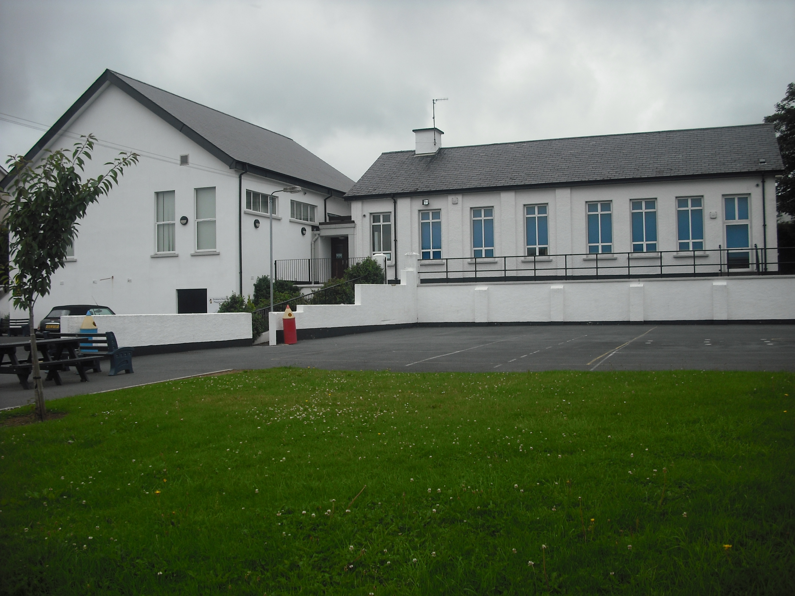
Dromore Road is a small controlled Primary school situated in the town of Warrenpoint. We provide a broad and balanced education for children from P1 – P7.

.

Volunteer Policy


The school’s volunteer policy is part of the school’s safeguarding system and policy.
Introduction
When children are enrolled at Dromore Road Primary School, teachers, parents and other key adults in a child’s life, become partners in their care and education. Through complementary roles, mutual support and open communication the bond between home, community and school can greatly enrich a child’s general progress and experience of school.

Volunteers at our school bring with them a range of skills and experience that can enhance the learning opportunities of pupils. The Board of Governors therefore, welcomes and encourages volunteers from the local community. However, without wishing to dissuade or offend those who are enthusiastic and generous with their commitment to school, it is important that we follow procedures that will give confidence to children, parents and staff and to the volunteers themselves.

Our volunteers may include but is not limited to:
• Members of the Governing Body
• Parents of pupils
• Ex-pupils
• Students on work experience
• Ex-members of staff
• Friends of the school/ local community

The intake of volunteers will be dependent on the candidate and available spaces within school. The smooth running of Dromore Road Primary School for our pupils will always be the priority. The Principal maintains the right to refuse volunteers and also terminate placements. The types of activities that volunteers may engage in, on behalf of the school, include:
- Reading partnership with pupils
- Working with small groups of pupils to assist them in their learning
- Assisting with after school activities, e.g. STEM
- Maintaining the school garden
- Accompanying school visits
Becoming a Volunteer

It is the school’s decision to take on volunteers and this will depend on the time of year, the number of volunteers we already have in school and the potential impact on the children. Anyone wishing to become a volunteer, either for a one-off event such as a school visit or on a more regular basis, e.g. hearing pupils read, should approach the class teacher or Principal directly. Occasionally, as the need arises, the school may approach parents to help volunteer and supervise with trips.

In the case of parents volunteering, many children are not ready to have their parents assisting the teacher in their own classroom as it may be difficult to adjust to a different relationship. Therefore, it is the policy of Dromore Road Primary School that it is better for the parent to volunteer to work in another area of school life than that involving their child.

Prospective volunteers should complete the Volunteer Application Form (appendix 1) with their contact details, types of activities they would like to help with, and the times they are available to help.

Child Protection and Safeguarding
Safeguarding is our priority and we follow the EA guidelines to ensure that we are a school committed to safeguarding pupils and expect our volunteers to share that commitment. The process of recruitment of regular volunteers mirrors the safer recruitment of paid staff to ensure the most suitable adults for our school. A list of volunteers will be kept in the main office- this will be kept up to date and is the responsibility of the Principal.
To ensure the safety of our pupils, we adopt the following procedures:
- All volunteers are given a copy of the Volunteer Policy and asked to sign a Volunteer Agreement prior to commencing a volunteering role (Appendix 2)
Under Disclosure and Barring Arrangements, whether a volunteer is supervised will determine if he/she is working in Regulated Activity or not, which will then influence if an Enhanced Disclosure Certificate (EDC) from Access NI is required. It will be a matter for Dromore Road’s management to determine whether the volunteers working in school are viewed as in “Regulated Activity” or whether the school can ensure there is reasonable supervision of the volunteer on a regular basis.
regular basis. In these circumstances. Regular volunteers who are not supervised are regarded as working in Regulated Activity and therefore an Enhanced Disclosure Check (EDC) from AccessNI is required. If a volunteer does not have a EDC they should not, under any circumstances, be left with a child alone.
- Volunteers will meet with the principal prior to working in the school to determine their role and a designated staff member will be allocated to support them in their role.
- Volunteers agree to the visitor’s code of practice daily when they sign the visitor’s book at reception

Visitor’s Code of Conduct
  - Visitors will be asked to confirm their identity upon arrival.
  - Visitors should sign in and out of the building, providing contact details for PHA Track and Trace.
  - A visitor’s badge should be worn, and be clearly visible, when on the school premises.
  - Visitors must follow the school’s hygiene practices and current PHA guidance related to handwashing, sanitizing, social distancing, wearing a face mask etc.
  - Visitors should stay within the areas that are necessary for your visit.
  - Respect all in the school community. Use appropriate language and behaviour with children, staff and parents. Behaviour which is regarded as unacceptable includes:
-Physical abuse, threatening, oppressive or aggressive behaviour or use of offensive language towards other adults, staff or children
-Entering the school site under the influence of alcohol or drugs
-Smoking or vaping anywhere on the school site

- Visitors must follow the school’s Emergency Evacuation Procedure - If you hear the fire alarm sound, leave by the nearest exit and report to the fire assembly point in the school playground so that you can be accounted for.
- Visitors must comply with the school’s confidentiality policy.
- Any safeguarding or child protection concerns or disclosures must be reported immediately to the Principal (Mrs Mc Grath) or Mrs English/Mrs K Graham who are designated teachers for Child Protection in the school.
- Visitors should avoid ever being left alone with a child or children. If you feel any way uncomfortable about the behaviour of a child please discuss this with the Principal or the designated child protection teacher, Mrs English.
- Visitors should never give a pupil a lift in your vehicle unless you have appropriate insurance, parental consent and a member of staff present.
- Mobile phones should not be used when on site. In an emergency please use the phone in the main office.
- All photography and filming within school is prohibited unless permission is granted from the Principal.
- If a child attempts to make contact with you through a social networking site, screen print the page, inform the Principal as soon as possible and do not respond.
- All visitors should be aware that Dromore Road Primary School has policies in place for Whistleblowing, Child Protection and Safeguarding and E-Safety Policies- these are available on the school website or at the main office.
- Clothing should be respectful of pupils, staff and the working environment and community.
- Professionals should wear appropriate identification and if appropriate, bring proof of their Enhanced Disclosure Certificate.
- We request that all professionals make appointments so that their visit is organised and purposeful and does not interfere with the classroom learning.
- Follow the hygiene practice in place and current government guidance related to social distancing, wearing a face mask etc.

In addition, visitors must not enter our school buildings if:

- you have symptoms of Covid-19:

- a temperature/fever (above 37.8C).
- a new, continuous cough.
- change in your sense of taste or smell.

- you have cold or flu symptoms.

- you have suffered from vomiting or diarrhoea within the last 48 hours.

- if you or anyone in your household is required to self-isolate in accordance with PHA guidelines.

E- Safety
Online safety relates to the teaching and learning of technology in a responsible and safe environment, focusing on raising awareness of the core messages of safe content, contact and conduct when using it. Issues can include accessing websites and online content, email, online chat rooms, mobile phones, gaming and games consoles, social networking sites, instant messaging, viruses and spam. Volunteers, like staff are expected to follow the E-Safety Policy which is available from the main office or the school website. Mrs Louise English is the E-Safety Co-ordinator.

Personal devices including mobile phones that connect to the internet should not be used in school during class time. Staff may not make or receive calls during teaching time. Use of phones or phone watches must be limited to non-contact time when no children are present. Staff should keep devices out of sight when on school property. Staff must only use school owned devices for capturing, recording and storing data or photos of children.

Process for recruiting a regular volunteer who may be unsupervised and are regarded as working in Regulated Activity
A) The Principal will identify the need and role for volunteers

B) Candidates will be attracted by means of the school communications system

C) Volunteers will be directed to the school office and will be given the volunteer policy. The staff will either complete Appendix 1 with them or ask them to complete Appendix 1 and return. Two names of references will be requested.

D) The candidate/s attend the school for an informal discussion to ensure the applicant is suitable for the role.

E) An Enhanced Disclosure Certificate from AccessNI will be undertaken.

F) The volunteer will be made aware of the role and responsibilities they will be undertaking.

G) Two references will be sought where the volunteer arrangement will continue on a regular basis.

H) Induction- key school policies and documentation explained and issued. These include Pastoral Care, Child Protection and Safeguarding, Positive Behaviour and Whistleblowing Policy

I) Volunteer records to be kept in a central place within the school
Before starting to help in a school, a volunteer should complete the Volunteer Agreement (Appendix 2), which sets out the school’s expectations of its volunteers.

Work Experience/ Placement Students
Dromore Road Primary School has a long standing relationship with various local secondary schools, colleges and universities. We are happy to take students on placement if we have suitable experiences available based on the smooth running of Dromore Road. Secondary schools, colleges and universities wanting students to be placed with us need to formally make contact with the Principal outlining the aims of the placement and duration. If the placement is as part of a teaching course (BEd or PGCE) the Principal will deal with further correspondents/ details. If the placement is for work experiences purposes the school/ college is assumed to be the student’s reference and the student is requested to complete the volunteer’s paperwork. Dromore Road’s management retains the authority to refuse or terminate a placement to ensure the smooth running of the School.

Confidentiality
Volunteers in school are bound by a code of confidentiality. Any concerns that volunteers have about the pupils they work with/come into contact with should be voiced with the Principal or designated teacher, Mrs English and NOT with the parents of the child/persons.

Volunteers who are concerned about anything in the school, which may affect their work should raise the matter with the Principal or class teacher. Any information gained at the school about a child or adult should remain confidential.

Supervision
All volunteers will be assigned to a teacher or full-time member of staff. Teachers retain ultimate responsibility for pupils at all times, including the management of pupils’ behaviour and the activity they are undertaking.

Volunteers should have clear guidance from the designated supervisor (class teacher or full-time member of staff) as to how an activity is carried out/what the expected outcome of an activity is. In the event of any query/problem regarding the pupils understanding of a task, behaviour or their welfare, volunteers must seek further advice/guidance from their designated supervisor.

Health and Safety
The school has a Health & Safety Policy which is available from the school office. The Principal will ensure that volunteers are clear about emergency procedures (e.g. Fire Alarm Evacuation) and about any safety aspects associated with particular tasks (e.g. using cookery equipment) or the volunteer’s specific role. Volunteers need to exercise due care and attention and report any obvious hazards or concerns to the Principal.

Volunteers for school visits
School visits are an integral part of learning at our school and afford many pupils opportunities which are outside their usual experiences. Where a volunteer is engaged in a ‘one-off’ activity e.g. helping supervise a group of pupils as part of a class visit, no formal checks are required as such volunteers will be under the constant supervision of school staff. The class teacher or staff member leading the visit will brief the volunteer regarding the risk assessment, daily schedule and any other important pieces of information. The visit lead, who will be a staff member, has ultimate responsibility for the pupils. Pupils should never be left with an unchecked volunteer unsupervised.

Whilst on the trip volunteers are expected:
• To be responsible and look after, in equal measure, all of the pupils in your group under the instruction of the teacher organising the school trip.
• To stay with your allocated group of pupils, ensuring that their wellbeing and safety is maintained for the total duration of the school trip.
• To promote polite, respectful and courteous behaviour towards each other and members of the general public. We all go as ambassadors of our school!
• To ensure that your group keep up with the body of the school visit party, be it walking, entering or exiting from transportation or following speakers for the trip.
• To contact your child’s class teacher/member of staff if there are issues with first aid, safety and/or behaviour.
• To follow the schools E-Safety policy on the use of mobile phone procedures.
• To adhere to the school’s pastoral care and child protection policies.
• Show a commitment to their group, an interest in the focus of the visit and assist pupils in their learning by helping them to read signs/labels/information, asking questions that encourage pupils to think about the task and help to explain the areas of interest.
• Comply with all of the above whilst being under the direct supervision and guidance of school staff.

Volunteer helpers are not permitted:
- to bring additional children e.g. siblings or children in the care of the volunteer on the school trip.
-to smoke, vape, drink alcohol or engage in any illegal practices whilst undertaking their volunteer duties.
- to take photographs of pupils using personal devices.
- to give/buy their group treats e.g. ice creams, biscuits, sweets –before, during or after the school trip.

Volunteers’ Rights
Volunteers have the right to:
- be recognised for their valuable contributions to the educational experience of our children.
- be assigned worthwhile tasks;
- access any school policies and procedures that are relevant to their roles;
- receive any training or supervision that is necessary for the success of their activities;
- receive support and be assured that any complaint against them will be dealt with through the school’s complaints procedure.
- Make a complaint through the procedures outlined in the school’s Complaint Policy.

Complaints Procedure
In making any complaints made about a volunteer, the person concerned must follow the school’s complaints policy which is found on the school website or can be obtained from the school office.

Monitoring and Review
This policy will be regularly reviewed biannually by the Board of Governors.

Chairman: Date:
Principal: Date:

APPENDIX 1 VOLUNTEER APPLICATION FORM –FOR NEW VOLUNTEER

Name of Volunteer: …………………………………………………
Date of Birth: ……………………………………
Address: ……………………………………………………………………………………………………………………………….… ………………………………………………………………………………………………………………………………………………..
Home phone:………………………….. Mobile: ………………………………….

Please declare below any relationships with pupils or staff at Dromore Road.

What activities/areas of the school’s work would you like to help with?

Are there any particular age groups/classes you would like to work with?

Do you have any disabilities/other needs we need to take into account or adjustments we need to make to allow you to work as a volunteer in school? (Please give details)

Please provide details of two people who can provide professional references for you: (If this is a work experience placement from a secondary school you only need to provide the Principal’s name from the school that you attend)
1)Name: | 2)Name
Address: | Address:
Phone number: | Phone number:

Thank you for taking time to complete this Volunteer Application Form

Please hand it to the school office, marked for the attention of the Principal. Your offer of help is greatly appreciated and we will be in touch as soon as possible.

APPENDIX 2 VOLUNTEER AGREEMENT
Thank you for offering your services as a volunteer at school. Your offer of help is greatly appreciated and we hope that you will gain much from your experience. Please read and sign this Volunteer Agreement Sheet and hand it in at school. You will receive a copy of it for your records.

• I will follow Dromore Road’s Child Protection and Safeguarding Policy.

• I have received a copy of the School’s Volunteer Policy.

• I will follow the Visitor’s Code of Conduct

• I agree to treat information obtained from being a Volunteer in School as Strictly Confidential

• I understand that an Enhanced Disclosure Certificate (EDC) from Access NI is required for regular and unsupervised volunteers.

• If you already have an Access NI Certificate, please hand it to the school, the number will be recorded and checks made with the issuing body.

• I have been made aware of who is my designated supervisor e.g. Class Teacher, Classroom Assistant, Principal

• I agree to follow the E-Safety Policy

Signed: ___________________________

Name: ____________________________

Date: _____________________________

