Term:- 3 Date: April - June 2017
TOPIC – Project – Anywhere Island
 | Reading | Writing | Talking & Listening
Literacy | - Know the terms ‘adventure’ and ‘mystery’ and understand them as a fiction genre. Investigate:  - Significant features of the genre, e.g. opening, build-up, atmosphere.  - The importance of point of view, distinguishing between 1st and 3rd person accounts  - Credibility of events  - Typical character types and settings  - Know and understand the following terms and identify them in poems: verse, chorus, couplet, stanza, rhyme, rhythm, alliteration other patterns of rhyme.  - Know the concept of form in poetry, e.g. acrostics, haiku.  - Begin to understand the concepts of ‘audience’ and ‘purpose’  - Understand that letters are written for a range of purposes, e.g. to recount, explain, enquire, complain, congratulate, and comment.  - Know the layout of letters, including use of paragraphs, ways of starting, ending etc… and ways of addressing different audiences – formal/informal.  - Know how to locate information quickly and accurately, e.g. by scanning and skimming.  - Know how to summarise orally the content of a passage or text in order to identify the main points.  - Know how to use the Dewey classification system.  - Identify social, moral or cultural issues in stories, e.g. the dilemmas faced by characters or the moral of the story and to discuss how the characters deal with them; locate evidence in text.  - Understand how paragraphs or chapters are used to  collect, order and build up ideas. | - Plot a sequence of episodes modelled on a known story, as a plan for writing  - Write openings to stories or chapters linked to or arising from reading; focus on language to create effects, e.g. building tension, suspense, creating moods, setting scenes.  - Write a 1st person account, e.g. write a character’s own account of an incident in the story.  - Write poems similar in style to those studied.  - Select style and vocabulary appropriate to the intended reader when writing letters, notes and messages linked to work in other subjects, e.g. to communicate within the school, letters to authors about books.  - Organise letters into simple paragraphs.  - Use ICT to bring to published form. Discuss relevance of layout, font etc… to audience.  - Experiment with recounting the same event in a variety of ways for different audiences, e.g. in the form of a letter, a story, a poster.  - Make clear and concise notes for a purpose  - Explore the main issues of a story by writing a story about a dilemma and the issues it raises for the character.  - Organise writing in paragraphs using clear chronological stages.  - Write own longer stories from story plans. | - Adapt behaviour and language to suit the different situations and audiences.  - Offer reasons and evidence for their views, considering alternative opinions.  - Understand and learn to respond to feedback.  - Use and explore different question types – to clarify, to plan and to set goals.  - Understand more than one point of view.  - Identify the main points made by each speaker.  - Choose and prepare poems and stories for performance.

 | Number | Measures | Shape & Space | Handling Data
Numeracy  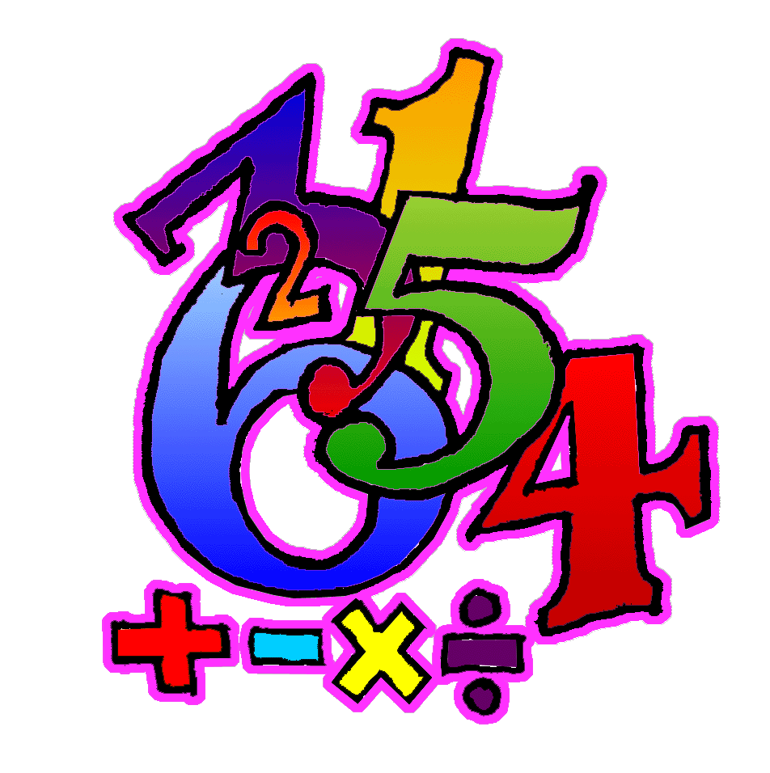 | - Count forwards and backwards in multiples of 3,4,5,6,7,8,9 within 100.  - Understand equivalence of fractions, where the numerator is 1 (e.g. find fractions which are equivalent to 1/5).  - Find fractions of quantities (numerator = 1), using links with division facts.  - Understand the 7 and 9 times multiplication facts. Derive corresponding division facts, using understanding of inverse relationships.  - Use written multiplication methods to multiply a 2/3 digit number by any single digit number.  - Develop a written method for division calculations within 999.  - Solve a range of addition, subtraction, multiplication and division problems, using both written and mental methods, selecting the operation required.  Use function machines calculating input, output or operation.  - Compare different ways of spending a fixed budget up to £100.00.  - Calculate estimated costs by rounding prices to the nearest pound, 50p or 10p as appropriate.  - Discuss ways of managing money effectively: e.g. deciding on best value when considering different options, putting money into savings account etc. | - Estimate, measure and record short lengths in mm.  - Discuss how to measure lengths more accurately – use cm and mm.  - Appreciate and use relationship between mm and cm to convert between mm and cm and mm e.g. 32 mm is equal to 3 cm and 2mm.  - Find more efficient methods to calculate perimeter of shapes, e.g. find perimeter of rectangle by adding two lengths then doubling.  - Know and use gram equivalents of 1kg, ½ kg, ¼ kg, ¾ kg and 1/10 kg.  - Know ml equivalents of 1 litre, ½ l, 1/4l, ¾ l and 1/10 l. Use these to explore containers of different sizes.  - Find more efficient methods for finding the area of shapes by counting squares and rectangles e.g. count how many squares are in 1 row (or column), and multiply by the number of rows (or columns).  - Use relationship between hours and minutes when calculating (e.g. start time 10:24 am, finish time 12:12 pm, find duration in hours and minutes).  - Know there are 60 seconds in 1 minute and use to convert time durations between seconds and minutes and seconds.  - Understand patterns within calendar dates; link with 7 times tables. | - Match nets with a range of 3D shapes.  - Draw nets and use to construct a range of 3D shapes.  - Identify the numerical co-ordinates of given points (first quadrant only).  - Calculate direction and amount of turn using simple maps.  - Understand need for a standard unit of turn, smaller than a right angle. | - Insert relevant information into a computer database with fields already created.  - Use sort and search functions to answers questions with up to 2 criteria.  - Discuss the likelihood of particular events occurring, using terms “impossible”, “unlikely”, “likely”, “certain”.
Processes: (Ongoing throughout the year, but all processes activities this term will be linked to areas covered above as well as revising previous concepts).
- Begin to organise own work and to work systematically.
- Solve simple two-stage problems set in real life contexts.
- Begin to suggest how to present findings.
- Use a writing frame to plan what is needed to start solving a problem.
- Talk about how they carried out a task.
- Discuss and respond to open ended questions.
- Discuss and compare ideas and methods with others.
- Where appropriate, select or design a writing frame to plan work.
- Explain their thinking.
- Compare own methods/findings/presentation with that of others.
- Begin to explore and use a range of problem solving strategies, persevering when difficulties are encountered.
12. Check accuracy of own work and findings

