Term:- 3 Date: April - June 2017
TOPIC – Project – Anywhere Island
 | Reading | Writing | Talking & Listening
Literacy | - Know the terms ‘adventure’ and ‘mystery’ and understand them as a fiction genre. Investigate:  - Significant features of the genre, e.g. opening, build-up, atmosphere.  - The importance of point of view, distinguishing between 1st and 3rd person accounts  - Credibility of events  - Typical character types and settings  - Know and understand the following terms and identify them in poems: verse, chorus, couplet, stanza, rhyme, rhythm, alliteration other patterns of rhyme.  - Know the concept of form in poetry, e.g. acrostics, haiku.  - Understand that letters are written for a range of purposes, e.g. to recount, explain, enquire, complain, congratulate, and comment.  - Know the layout of letters, including use of paragraphs, ways of starting, ending etc… and ways of addressing different audiences – formal/informal.  - Know how to locate information quickly and accurately, e.g. by scanning and skimming.  - Know how to summarise orally the content of a passage or text in order to identify the main points.  - Identify social, moral or cultural issues in stories, e.g. the dilemmas faced by characters or the moral of the story and to discuss how the characters deal with them; locate evidence in text.  - Understand how paragraphs or chapters are used to  collect, order and build up ideas. | - Plot a sequence of episodes modelled on a known story, as a plan for writing  - Write openings to stories or chapters linked to or arising from reading; focus on language to create effects, e.g. building tension, suspense, creating moods, setting scenes.  - Write poems similar in style to those studied.  - Organise letters into simple paragraphs.  - Use ICT to bring to published form.  - Experiment with recounting the same event in a variety of ways for different audiences, e.g. in the form of a letter, a story, a poster.  - Explore the main issues of a story by writing a story about a dilemma and the issues it raises for the character.  - Organise writing in paragraphs using clear chronological stages.  - Write own longer stories from story plans. | - Choose and prepare poems and stories for performances, identifying appropriate expression, tone and volume.  - Present information ensuring that items are sequenced and relevant details are included.  - Ask focussed questions.  - Clarify and retain what they have heard, e.g. by rephrasing.  - Use talk functionally in groups in order to get things done.  - Identify and discuss qualities of others’ performances, including gestures and actions.

 | Number | Measures | Shape & Space | Handling Data
Numeracy  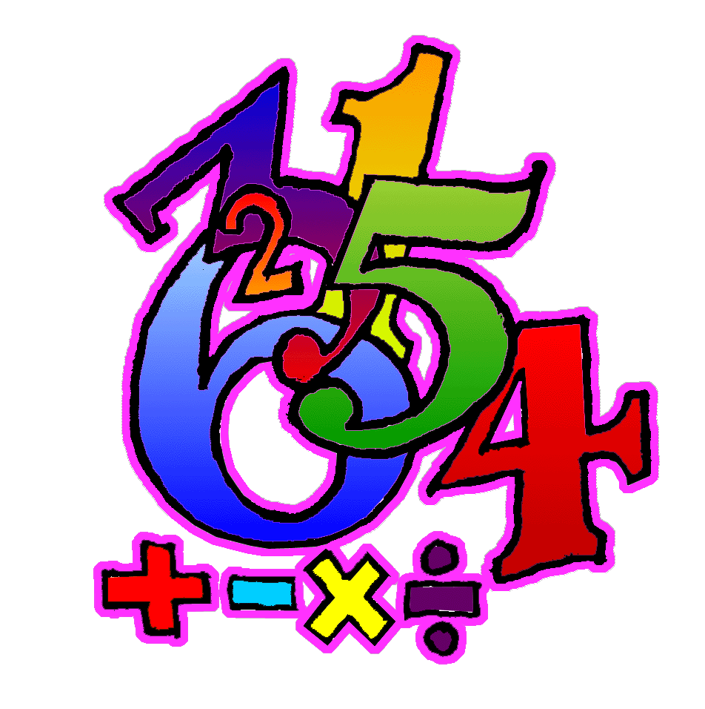 | - Order numbers (increasing and decreasing) within 999.  - Round numbers within 999 to the nearest 100 and the nearest 10.  - Understand links between fractions of a set and division. (e.g. finding how many objects make half of a total set is equivalent to dividing the number by 2).  - Develop a standard written method for vertical addition HTU (with carrying).  - Give an approximate answer for written subtraction calculations.  - Add/subtract 9/ 19/29/39 etc.. to any number (initially using 100 square.  - Know doubles of multiples of 10 up to double 50.  - Use knowledge of place value to develop a practical method for vertical subtraction. HTU (no exchange), estimating the answer before calculating  - From 3 given numbers within 50 give 4 number facts.  - Solve a range of addition and subtraction problems, using both written and mental calculations, selecting the operation required.  - Understand the 3 and 4 times multiplication facts as repeated addition, and as arrays. Develop quick recall, using understanding of commutativity. Understand links between 2 and 4 times tables.  - Know with quick recall multiplication facts for 2, 5, 10 and apply in problem-solving situations.  - Understand sharing and grouping concepts of division through practical activities.  - Appreciate that multiplication and division are inverse operations.  - Deduce relevant division facts from 2 times multiplication facts.  - Understand that finding ‘half’ of a total is equivalent to dividing that total by 2.  - Compare different ways of spending a fixed budget up to £10.00.  - Calculate estimated costs by rounding prices to the nearest pound, 50p or 10p as appropriate. | - Estimate and measure short lengths in centimetres.  - Discuss how to measure lengths more accurately – use metres and cm.  - Use different measuring instrument, knowing how to use each one with reasonable accuracy.  - Discuss and select an appropriate unit and measurement device for a particular job.  - Estimate and measure the weight of lighter objects in multiples of 100grams.  - Discuss how to weigh items more accurately – use Kg and grams.  - Use different measuring instruments, knowing how to use each one with reasonable accuracy.  - Discuss and select an appropriate unit and measurement device for a particular job.  - Estimate and measure the capacity of smaller containers in multiples of 100 millimetres.  - Discuss how to measure the capacity of containers more accurately – use litres and millilitres.  - Use different measuring instruments, knowing how to use each one with reasonable accuracy.  - Discuss and select an appropriate unit and measurement device for a particular job.  - Through using different size squares, appreciate the need for a standardised square to measure and compare areas.  - Calculate start, finish durations, how long until? How long since? Using multiples of 5 minutes, including counting through the hour.  - Know the number of days in each month. | - Identify which 2D shapes will tessellate and which will not.  - Identify right angles in the environment, using a right angle tester.  - Identify angles in 2D shapes which are greater than or less than a right angle.  - Understand that there are always two ways to turn towards a particular direction e.g. ¼ turn clockwise or ¾ turn anti-clockwise will have the same effect.  - Use simple grid references to identify a particular square on a grid. | - Discuss the labelling of frequency axis on bar charts.  - Identify situations where labelling may not be in ones (e.g. where the frequency is too great for the axis to fit on the page).  - Discuss, draw and label bar charts which require scales, using paper and ICT, interpret results and draw appropriate conclusions.  - Investigate statements to see if they are true or false using data handling skills to identify and collect data, display data graphically and interpret results.  - Access information using a computer database (e.g. Information Workshop 2000) answering questions.
Processes: (Ongoing throughout the year, but all processes activities this term will be linked to areas covered above as well as revising previous concepts).
- Select appropriate materials and equipment for a task through an understanding of their special characteristics.
- Choose and use appropriate number operations and ways of calculating in a wide range of contexts.
- Suggest the information needed to carry out a task, how to obtain the information and ways to record it.
- Ask questions to clarify information.
- Discuss and respond to open-ended questions.
- Present findings in an appropriate way.
- Begin to talk about how they carried out a task.
- Review own way of working with (teacher/peers).
- Consider alternative ways of working (with teacher/peers).
- Check accuracy of own work (with teacher/peers).

